
Name: Precious Mumbe John
Admission Number: BSCCS/2024/42696
Course: Computer Science
Unit Code: BIT4139
Unit Name: ETHICAL HACKING AND COUNTERMEASURES
Lecturer Name: MICHAEL NYORO
Semester: 4.1

TABLE OF CONTENT
Contents
Week 1: Introduction to Ethical Hacking 2
Setting Up the Kali Linux Lab Environment 2
Identifying and installing an open source tool 3
Week 2: Penetration Testing Basics 3
Running Vulnerability Scans 3
Week 3: Footprinting and Reconnaissance 5
Performing DNS and social engineering foot printing 5
Week 4: Scanning Networks 6
Conducting Port Scanning 6
Week 5: Enumeration 8

TABLE OF FIGURES
Figure 1: Installation of VirtualBox 3
Figure 2: Installation of Nmap 3
Figure 3: Scan target for open ports 4
Figure 4: Detects service versions 4
Figure 5: Identifies windows version 5
Figure 6: Identifies possible weaknesses 5
Figure 7: Obtaining company IP address 6
Figure 8: Domain registrar obtained using WHOIS 6
Figure 9: Microsoft Outlook / Microsoft 365 (Exchange Online) used as the email service 6
Figure 10: Subdomains discovered using DNSDumpster 7
Figure 11: Open ports and services identified using Nmap 8
Figure 12: Testing the running services 9
Figure 13:Failure in identifying the OS version 9
Figure 14: Technologies used by Kenya airways 9

Week 1: Introduction to Ethical Hacking

Setting Up the Kali Linux Lab Environment
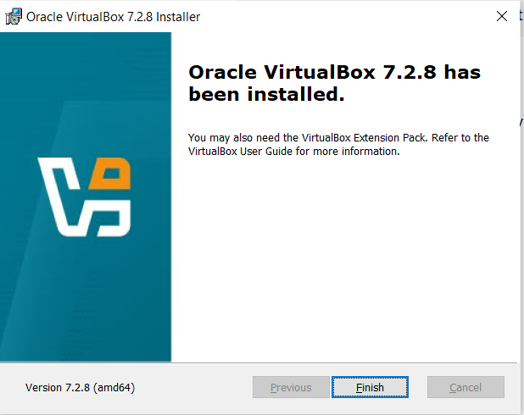
Figure 1: Installation of VirtualBox

Identifying and installing an open source tool

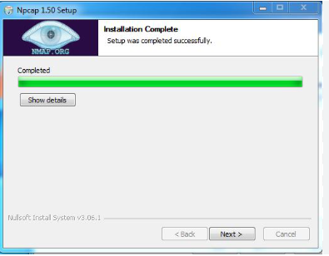
Figure 2: Installation of Nmap

My Reflection
This week introduced me to ethical hacking and the importance of creating a safe testing environment. I learned how Kali Linux and VirtualBox are used to create a cybersecurity lab without affecting the host operating system. I also understood the role of ethical hackers in identifying and reporting security weaknesses responsibly. Setting up the environment helped me appreciate the practical side of cybersecurity and prepared me for the hands-on activities in the following weeks.

Week 2: Penetration Testing Basics

Running Vulnerability Scans
Objective: To identify open ports, active services, and possible vulnerabilities on a target system using Nmap.
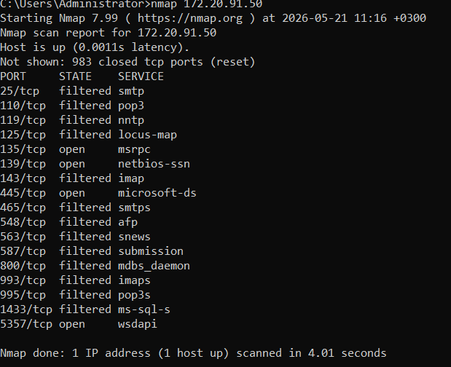
Figure 3: Scan target for open ports
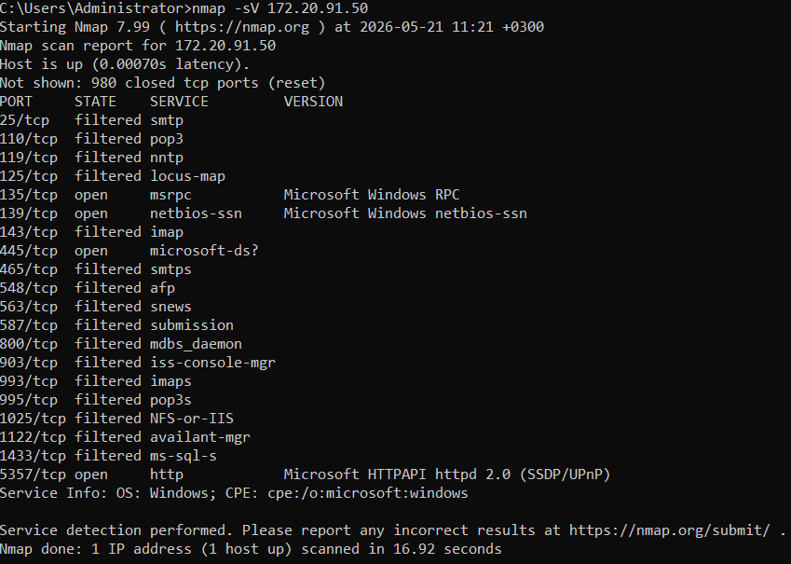
Figure 4: Detects service versions

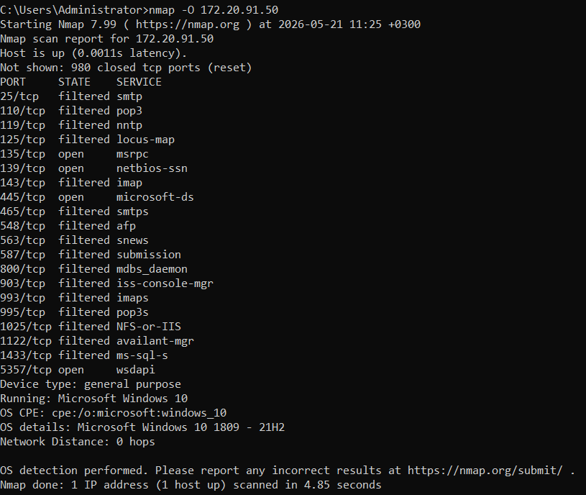
Figure 5: Identifies windows version

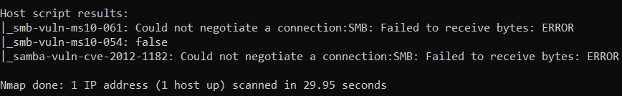
Figure 6: Identifies possible weaknesses

My Reflection
During this week, I learned the basics of penetration testing and vulnerability assessment. I used Nmap to perform scans and identify open ports and services. I also explored Nmap documentation and understood how different scanning options work. The practical exercises helped me understand how security professionals identify weaknesses in systems before attackers can exploit them. This week improved my confidence in using cybersecurity tools and interpreting scan results.

Week 3: Footprinting and Reconnaissance

Performing DNS and social engineering foot printing

Target Organization: Kenya Airways

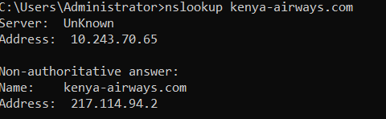
Figure 7: Obtaining company IP address

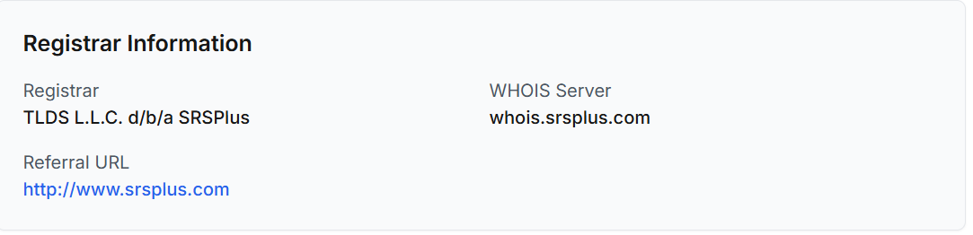
Figure 8: Domain registrar obtained using WHOIS

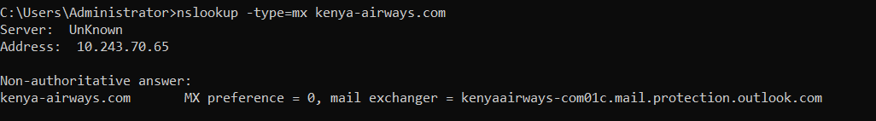
Figure 9: Microsoft Outlook / Microsoft 365 (Exchange Online) used as the email service

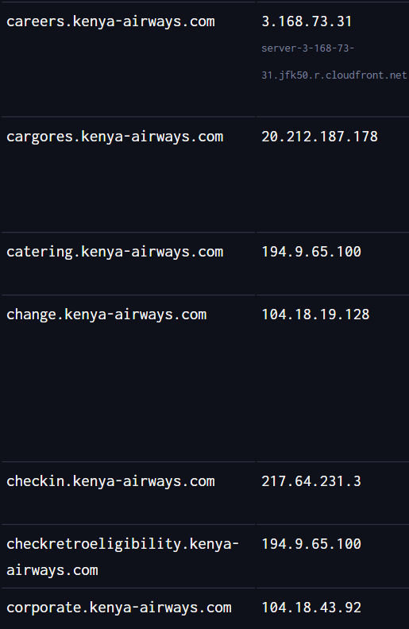
Figure 10: Subdomains discovered using DNSDumpster

My Reflection
This week focused on foot printing and reconnaissance. I learned how to gather information about a target organization using publicly available sources. Through activities such as domain lookup, DNS analysis, registrar identification, email infrastructure discovery, and subdomain enumeration, I gained a better understanding of how much information can be obtained without directly interacting with a target system. This week emphasized the importance of information gathering as the foundation of any security assessment.

Week 4: Scanning Networks

Conducting Port Scanning

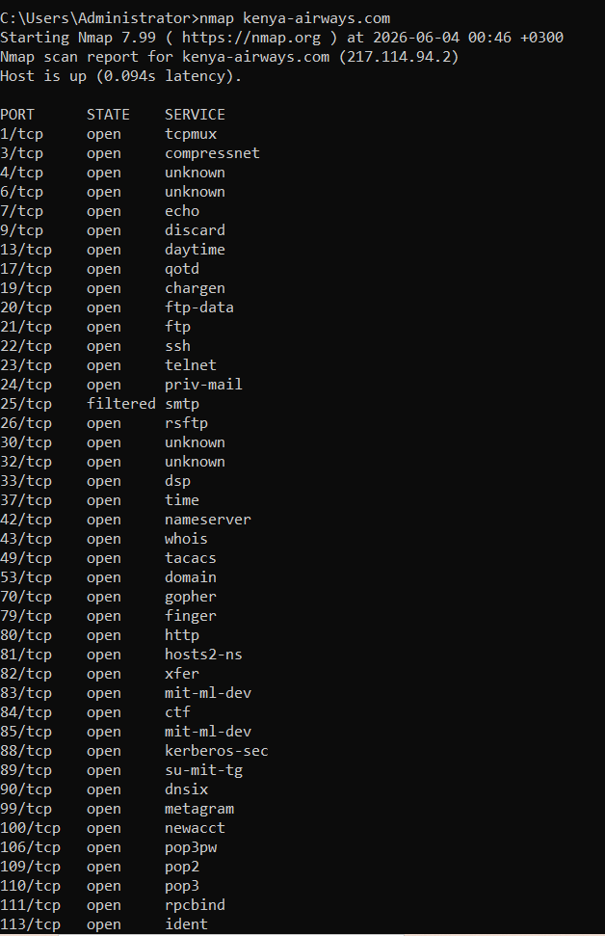
Figure 11: Open ports and services identified using Nmap

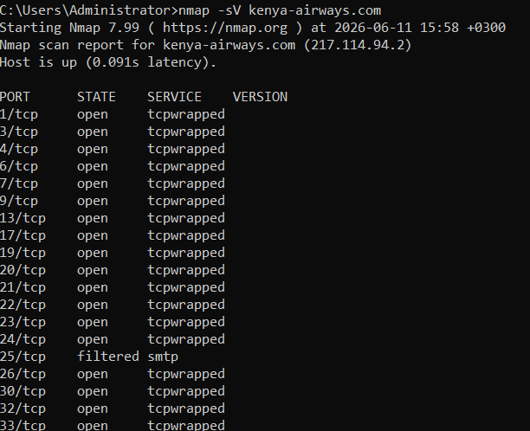
Figure 12: Testing the running services

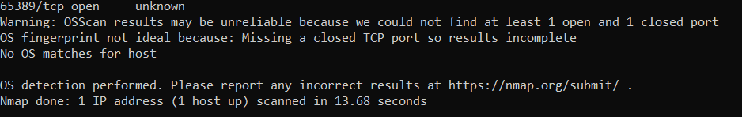
Figure 13:Failure in identifying the OS version

My Reflection
This week introduced network scanning techniques using Nmap. I learned how to identify active hosts, discover open ports, and detect available services on target systems. Through practical exercises, I understood the importance of scanning in identifying potential entry points within a network. I also learned how security controls can affect scan results and how to interpret the information gathered during the scanning process.

Week 5: Enumeration

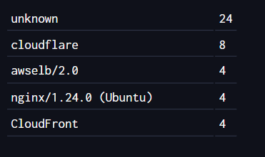
Figure 14: Technologies used by Kenya airways

